CSE3012: Database Design Lab

**Worksheet 3**: Constraints, Joins

Given below is the schema diagram of a bank database. Apart from the primary key and foreign key constraints, it the following two constraints:

* Assets must always be greater than or equal to zero in the BRANCH table
* Balance must always be greater than or equal to zero in the ACCOUNT table

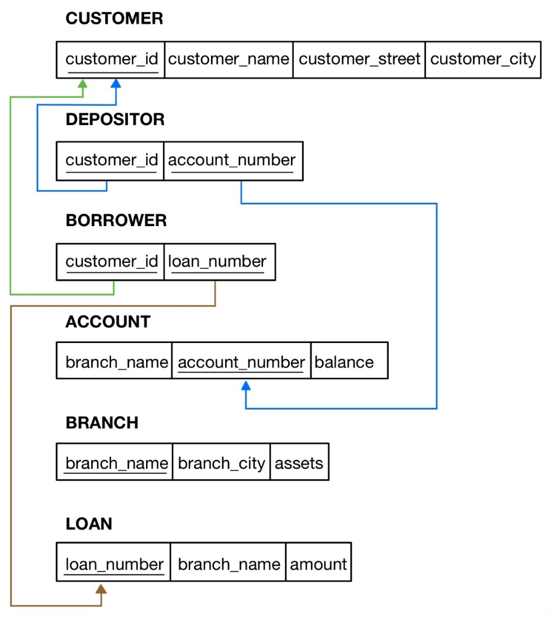

The aforementioned database is populated with the data given below.

**CUSTOMER**

+-------------+---------------+-----------------+---------------+

| **customer_id | customer_name | customer_street | customer_city** |

+-------------+---------------+-----------------+---------------+

| C-101 | Jones | Main | Harrison |

| C-201 | Smith | North | Rye |

| C-211 | Hayes | Main | Harrison |

| C-212 | Curry | North | Rye |

| C-215 | Lindsay | Park | Pittsfield |

| C-220 | Turner | Putnam | Stamford |

| C-222 | Williams | Nassau | Princeton |

| C-225 | Adams | Spring | Pittsfield |

| C-226 | Johnson | Alma | Palo Alto |

| C-233 | Glenn | Sand Hill | Woodside |

| C-234 | Brooks | Senator | Brooklyn |

| C-255 | Green | Walnut | Stamford |

+-------------+---------------+-----------------+---------------+

**DEPOSITOR**

+-------------+----------------+

| **customer_id | account_number** |

+-------------+----------------+

| C-101 | A-217 |

| C-201 | A-215 |

| C-211 | A-102 |

| C-215 | A-222 |

| C-220 | A-305 |

| C-226 | A-101 |

| C-226 | A-201 |

+-------------+----------------+

**BORROWER**

+-------------+-------------+

| **customer_id | loan_number** |

+-------------+-------------+

| C-101 | L-17 |

| C-201 | L-11 |

| C-201 | L-23 |

| C-211 | L-15 |

| C-212 | L-93 |

| C-222 | L-17 |

| C-225 | L-16 |

| C-226 | L-14 |

+-------------+-------------+

**ACCOUNT**

+-------------+----------------+---------+

| **branch_name | account_number | balance** |

+-------------+----------------+---------+

| Downtown | A-101 | 500 |

| Perryridge | A-102 | 400 |

| Brighton | A-201 | 900 |

| Mianus | A-215 | 700 |

| Brighton | A-217 | 750 |

| Redwood | A-222 | 700 |

| Round Hill | A-305 | 350 |

+-------------+----------------+---------+

**BRANCH**

+-------------+-------------+---------+

| **branch_name | branch_city | assets** |

+-------------+-------------+---------+

| Brighton | Brooklyn | 7100000 |

| Downtown | Brooklyn | 9000000 |

| Mianus | Horseneck | 400000 |

| North Town | Rye | 3700000 |

| Perryridge | Horseneck | 1700000 |

| Pownal | Bennington | 300000 |

| Redwood | Palo Alto | 2100000 |

| Round Hill | Horseneck | 8000000 |

+-------------+-------------+---------+

**LOAN**

+-------------+-------------+--------+

| **loan_number | branch_name | amount** |

+-------------+-------------+--------+

| L-11 | Round Hill | 900 |

| L-14 | Downtown | 1500 |

| L-15 | Perryridge | 1500 |

| L-16 | Perryridge | 1300 |

| L-17 | Downtown | 1000 |

| L-23 | Redwood | 2000 |

| L-93 | Mianus | 500 |

+-------------+-------------+--------+

**Task 1**

Create a bank database. Then, write SQL statements to create the relations in that database by referring to the schema. Ensure that you use sensible data types for the attributes by referring to both the database schema and state.

**Task 2**

Populate the database with the data given above.

**Task 3**

1. Find the names and cities of customers who have a loan at Perryridge branch
2. Find which accounts have balances between 700 and 900.
3. Find the names of customers on streets with names ending in "Hill".
4. Find the names of customers with accounts at a branch where Johnson has an account.
5. Find the names of customers with an account but not a loan at Mianus branch.
6. Find the names of branches whose assets are greater than the assets of some branch in Brooklyn.
7. Find the set of names of branches whose assets are greater than the assets of all branches in Horseneck.
8. Find the set of names of customers at Brighton branch, in alphabetical order.
9. Show the loan data, ordered by decreasing amounts and increasing loan numbers.
10. Find the names of each branch and the number of customers having at least one account at that branch.
11. Find the average balance of all customers in ‘Palo Alto’ having at least 2 accounts.